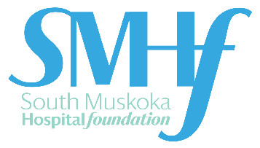
Confidential Statement of Future Intent

My Intention

I am pleased to confirm that I have included South Muskoka Hospital Foundation as a beneficiary of my estate plans as follows:

⃝ Bequest (Will) ⃝ Life Insurance Policy
⃝ Charitable Gift Annuity ⃝ Charitable Remainder Trust
⃝ Retirement Plan ⃝ Other Assets __________________

I estimate the current value of this gift to be $ __________________________ (confidential)

I understand that this declaration of intent will remain strictly confidential and is not legally binding.

Name: ________________________________________________ Birth date: ________________________

Address: ________________________________________________________________________________

City: _______________________________ Province: _____________________ Postal Code: ____________
Phone: ________________________________ Email: ___________________________________________
Signature: __________________________________________________ Date: _______________________
In Recognition:

All donors of planned gifts qualify for inclusion and recognition in the South Muskoka Hospital Foundation Legacy Society, which honors those who have remembered the hospital in their estate plans. Recognition is provided on our Donor Wall of Distinction in the main lobby of South Muskoka Memorial Hospital.

Please check one:

⃝ Yes, please my name may be publicly recognized. My name should appear as follows:_________________________________________________________

⃝ No, please do not publicly recognize me; I wish to remain anonymous.

our community is our foundation.
75 Ann Street, Bracebridge, ON P1L 2E4
T: 705-645-4404 ext. 3193 | F: 705-645-0352
www.healthmuskoka.ca

